Markov Decision Processes

Gary Saavedra

gsaavedra3@gatech.edu

Introduction

For this assignment BURLAP was used for Value Iteration (VI), Policy Iteration (PI), and SARSA. Each algorithm was run over 10 trials to average out some of the variance. To analyze the difference between the 3 algorithms 2 different Markov Decision Processes (MDP), a small grid and a large grid world were used. Reinforcement Learning is a difficult topic. There are two types of algorithms that can be deployed, a planner and a learner. A planner can be used when there is a model for the MDP the agent is trying to move through. Specifically there must be a transition function and a reward function. A learner can learn a policy even when there is no model. It does so by exploring the space.

Small Grid World

A small grid world with four rooms was used for the small MDP. It is shown in Figure 1. The small grid world has a total of 104 states. The agent starts in the bottom left corner and works its way to the goal state in the top right corner. The transition function is as follows: there is an 80% chance the agent will go in the direction intended and a 6.7% chance of moving in a direction that is not intended. The reward function gives a reward of 100 when the agent reaches the goal state. Otherwise, the agent receives a reward of -1 for any other state. This gives the agent motivation to end the game as quickly as possible.

*Why is it interesting?*

The small grid world will show the strength of the planning and learning algorithms. It allows for an analysis over many trials because the time needed is not too much.

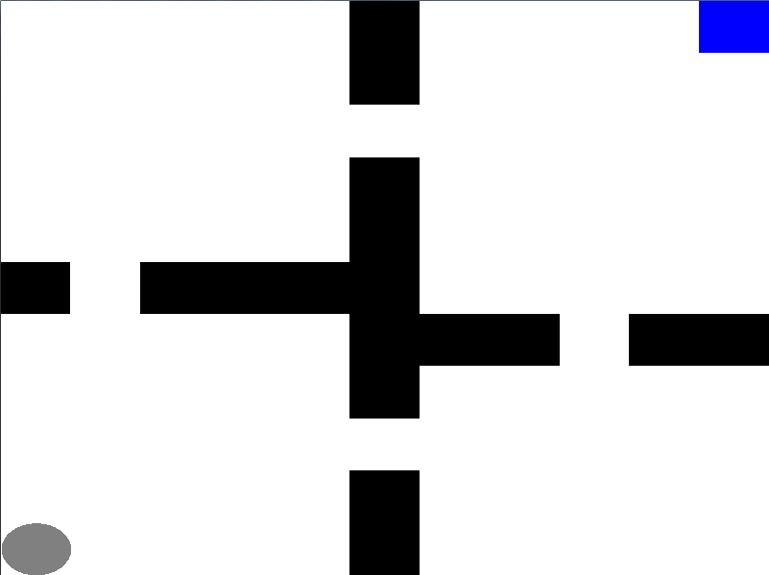

*Figure 1: Small Grid World*

Value Iteration

VI is a planning algorithm that utilizes the model from the space. It takes into account the Transitional probability and reward functions to search the space and maximize reward. It uses Bellman’s equation to iteratively update the utility of a state based on the utilities of the neighboring states. Bellman’s equation is recursive in that every utility update for a state requires the utility of neighboring states which in turn require the utilities for their neighboring states and so on. The process of recursively updating all the utilities is responsible for most of the time needed to perform by VI. VI is O(A*S2) in time complexity for each iteration where A is the total number actions from a state and S is the total number of states.

Talk about pros and cons? Needs a larger gamma to converge so it must look farther in the future. May be prohibitive in the large grid.

Figure 2 shows an iterations vs gamma graph for both PI and VI. The figure represents the number of iterations needed for convergence for a specified gamma. The VI always has a larger number of iterations no matter the choice of gamma. The number of iterations required for VI grows exponentially with increasing gamma. This is because the VI is required to look farther into the future to estimate utilities. Decreasing the discount factor decreases the number of iterations to find the optimal policy. But this is because the recursive application of the discount factor is making the difference between the later value functions smaller than delta much earlier than it would with a large discount value. This leads to a weak policy being found which in turn increases the number of iterations it takes for the agent to reach the absorbing state. This is because the optimal policy will only get an optimal value for the first few squares. After that the agent must choose randomly amongst the remaining squares. This can especially be seen with discount=0.99.

Figure 3 shows a time vs gamma graph for both VI and PI. The figure represents the amount of time needed for the algorithm to converge for a specified gamma. VI outperforms PI for all gamma choices greater than 0.6. PI only outperforms VI for 0.5 < gamma < 0.6. The time needed for convergence for VI decreases as gamma increases. At gamma = 0.5 the time needed is 44.4 ms (why is this larger for just gamma = 0.5). At gamma = 0.6 the time needed is 24.8 ms. The time increases as it moves up to gamma = 0.99. At gamma = 0.99 the time needed is approximately 52 ms.

Figure 4 shows a plot of rewards vs gamma for VI. The highest reward of approximately 75 is achieved when gamma = 0.99. At gamma = 0.7 VI comes very close to converging to an optimal answer. If VI is able to get to the goal without accidentally probabilistically taking a wrong direction it can get there in 21 steps. This would give it a reward of 79. Given the stochastic nature of the grid the VI has likely converged on the global optimum of 75. If time were a factor we could instead use a gamma of 0.7 and converge to a nearly optimal answer while saving time.

Graph ideas. Passes vs discount factor. Iterations needed to get to goal vs passes or discount factor. Convergence measure vs time

For VI a greedy Q policy is used which plans from the input state and returns a policy. This policy greedily selects actions with the highest Q value and breaks ties uniformly randomly. (See GreedyQPolicy in ValueIteration for more in burlap).

VI and PI converge to the same policy. This means either the VI found the true utilities or utilities that created the correct sequence of actions that led to the policy.

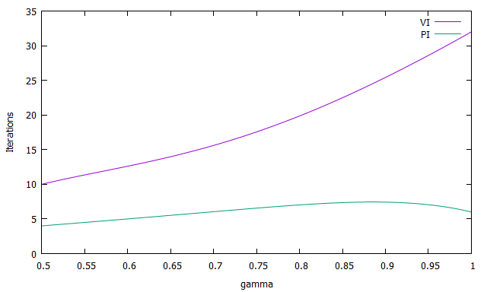

*Figure 2: Iterations vs gamma for PI and VI, Small grid*

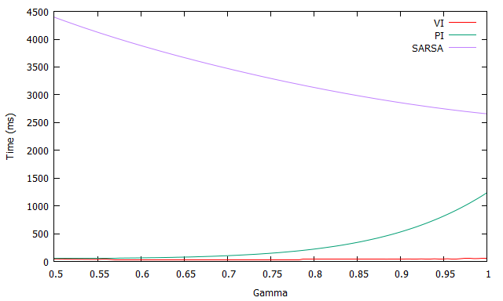

*Figure 3: Time vs gamma for PI and VI, Small grid*

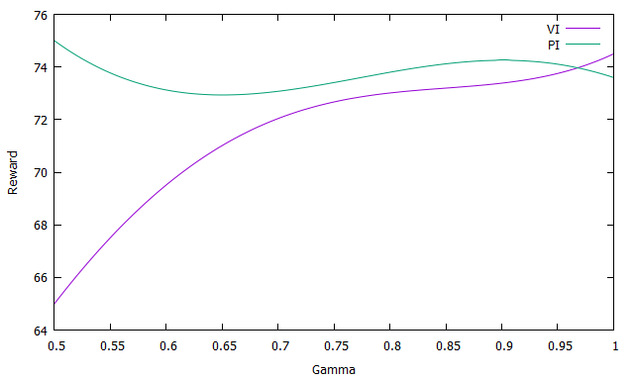

*Figure 4: Reward vs Gamma, Small grid world*

Figure 5 shows a policy map when gamma = 0.99. Here future reward is not being discounted much and thus the reward is able to propagate out from the goal state. The agent looks further into the future, the states closer to the goal, and is able to propagate the reward from those states to the earlier states. This creates a clear policy for the agent to follow.

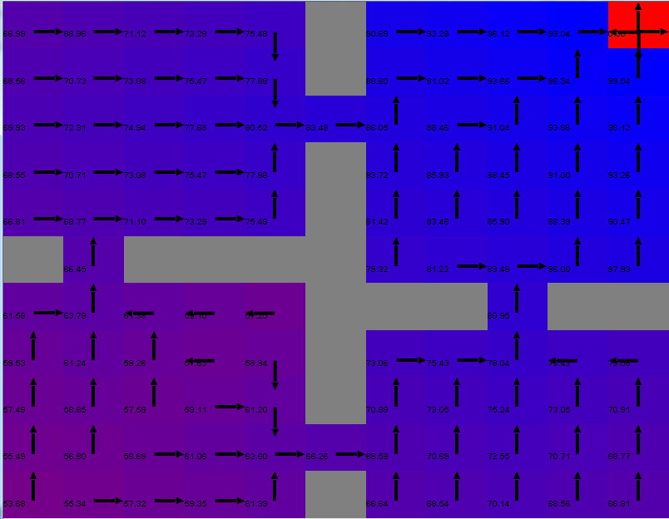

*Figure 5: VI, Policy map for gamma = 0.99*

Figure 6 shows a policy map when gamma = 0.5. Since future reward is discounted by such a large factor the utility is not able to propagate out from the goal state. The red indicates that the utility for those states is very low at about 5. The utility of approaching the goal state is not realized until a few squares before as shown by the blue in the top right corner. This is why some parts of the grid can show the agent wandering in non-ideal directions. The agent does not know about the future reward because it is too far away and has been discounted.

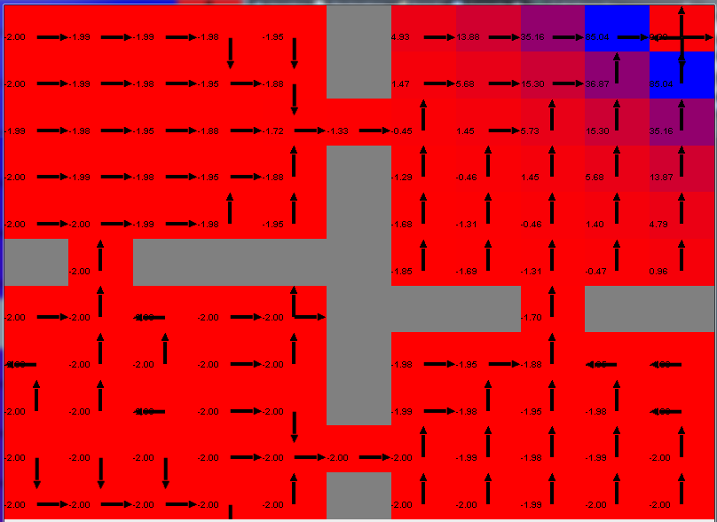

*Figure 6: VI, Policy map for gamma = 0.5*

**Policy Iteration**

Policy iteration typically takes less iterations to converge than value iteration. However, each iteration tends to be more expensive. Each iteration has an inner value iteration that computes a value based on actions defined by the current policy.

For both PI and VI number of iterations increases as gamma decreases. Good for a graph.

Figure 6 shows the policy map when gamma = 0.99. The policy is almost identical to the policy found by value iteration. The only difference is in the bottom left corner in the starting room. Explain why.

Figure 7 shows the policy map when gamma = 0.5. Similar to VI the small discount factor keeps the utilities from propagating out from the goal state. The policy found is different from the policy found with a larger gamma.

Figure 3 shows the time analysis for PI. PI is only able to outperform VI when 0.5 < gamma < 0.6. The time needed appears to grow exponentially as gamma approaches 1. Why does this happen? How is discount factor affecting this? The time needed when gamma = 0.99 is approximately 1500 ms compared to VI’s 75 ms. This is an increase by a factor of 20. The time complexity for each iteration of PI is O(A*S2 + S3) where A is the total number of actions available from a state and S is the total number of states.

Explain why I’m using gamma = 0.99 for all my choices.

Figure 2 shows the iteration analysis for PI and VI. PI takes many fewer iterations than VI. However these iterations tend to be more time expensive because of the large amount of work being done. Each iteration has several, possibly hundreds, of value iteration calculations. Each calculation runs a value iterations based on actions of the current policy. Thus each inner value iteration is not as computationally expensive because the computations are only needed for one action per state (this may not be right). The system of equations being solved is linear. Normal VI has a non-linear system of equations. The number of iteration needed by PI when gamma = 0.99 is 6 compared to the 33 iterations needed by VI. The PI curve stays relatively level no matter the gamma choice with either 5 or 6 iterations being needed.

Show the average time per iteration for VI and PI. PI iterations take longer and thus have a higher average. However, each iteration takes less time than the previous because it requires less value evaluations.

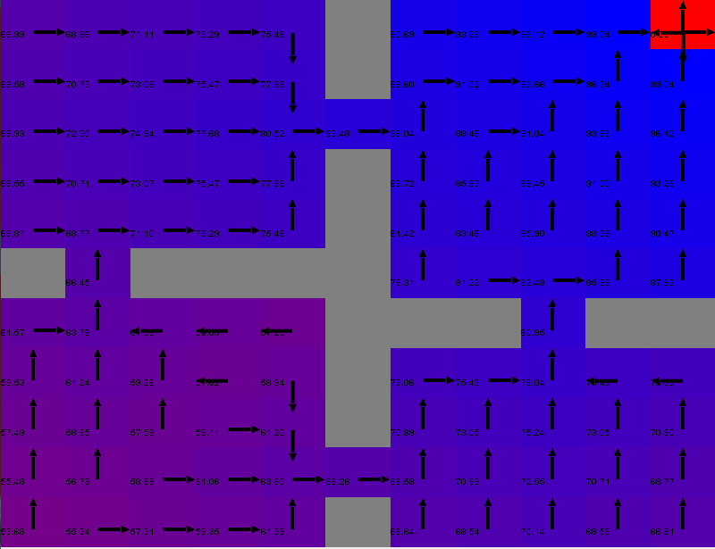

*Figure 6: PI, Policy map for gamma = 0.99*

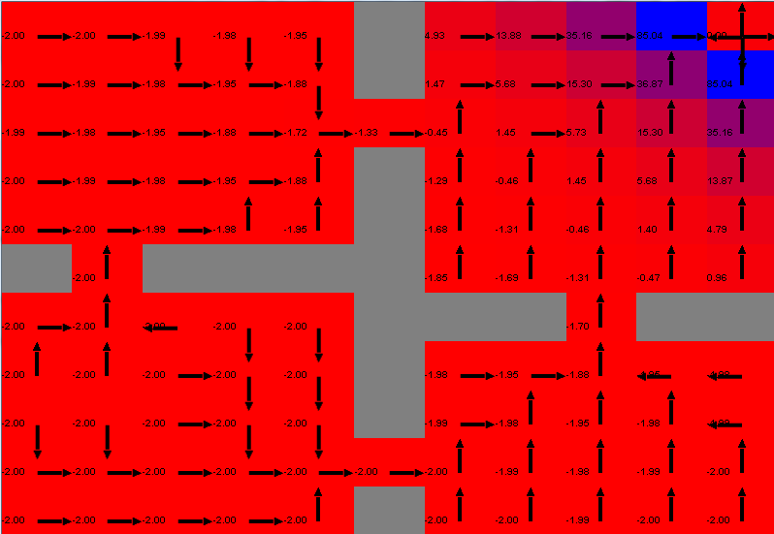

*Figure 7: PI, Policy map for gamma = 0.5*

**SARSA**

SARSA belongs to the family of Q-learning algorithms. It differs by the fact that when choosing the next state to move to it does not necessarily choose the state with the highest Q value. Instead it follows the policy that determined the original action and applies it to the new action.

SARSA is an on policy learner which means it tends to explore more. This is in contrast to the standard Q learner which is an off policy learner.

Figure … shows a comparison of two different learning rates for the SARSA algorithm. The blue line indicates a learning rate of 0.9 and the red line indicates a learning rate of 0.1. Both curves use an initial Q of 0.

Iteration analysis is not apples to apples with the other algorithms. This is because the agent is now moving through the environment to learn about it. An iteration therefore is one movement from the agent or a whole episode?

Figure … shows a comparison of two different initial Q values for SARSA. The red line indicates an initial Q of 0 and the blue line indicates an initial Q of 100. Overall the two different starting parameters cause the algorithm to converge to a similar policy which is obtaining the same average reward. However, with Q=100 SARSA takes much longer to converge.

SARSA takes less time for larger gammas because it can see into the future. It does not wander around the intial stages as much.

If you have space talk about how the steps change from episode to episode. First few episodes have a lot of steps and afterwards the number of steps kinda randomly osciallates amongst much lower numbers. Can kinda be seen in the av cum steps graph with the initial sharp increase.

Does reward for each episode add to all other rewards for each episode so that it’s cumulative. That would partly explain the poor performance

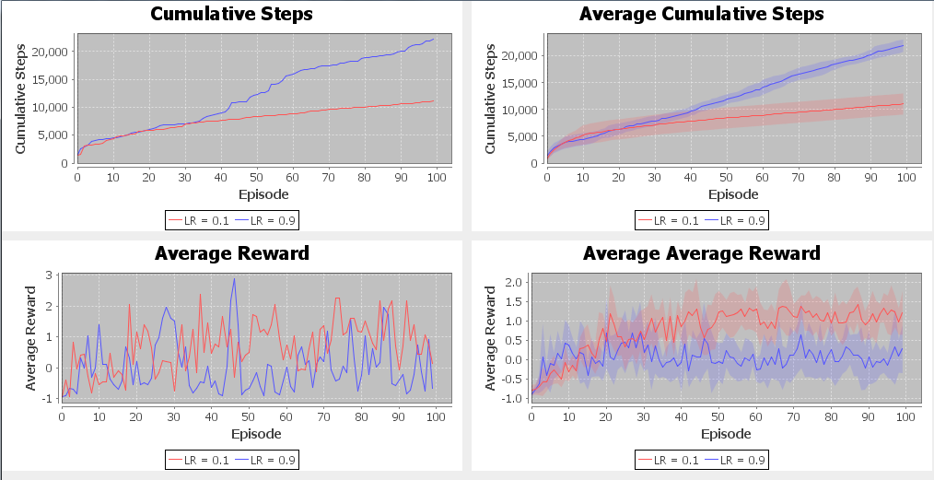

*Figure : Comparison for different learning rates for SARSA*

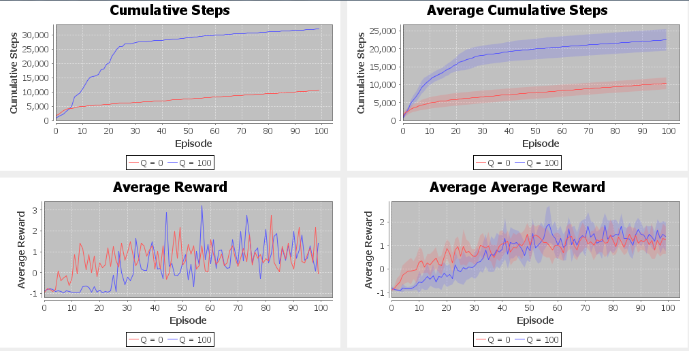

*Figure : Comparison for different initial Q values for SARSA*

**Large Grid World**

***Why is it Interesting?***

The large grid world is shown in Figure… The agent starts in the bottom left corner and is trying to reach the goal state in the top right corner marked by the blue square. There are 1614 states.

In the middle portion the agent must make its way through a winding section. The agent takes significantly more time through the winding section than when the section was just a straight travel through.

Talk about rewards fir reaching goal state etc.

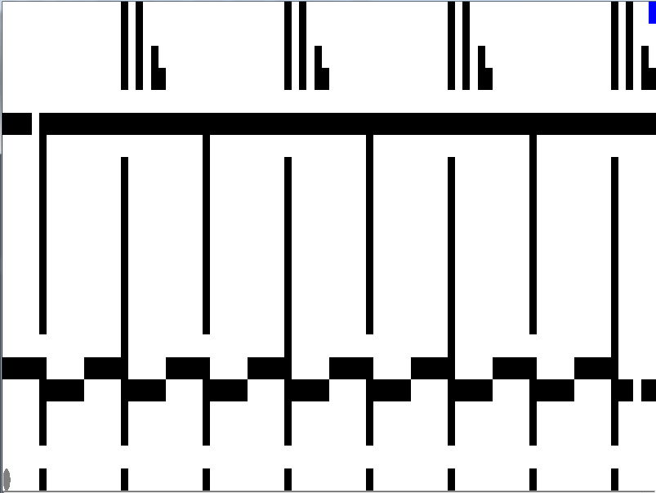

*Figure : Large grid world*

**Value Iteration**

At gamma = 0.99 VI takes approximately 9.7 seconds and PI takes 1114.7 seconds.

Number of states has increased by 15 fold but time has increased at least 100 fold(check this number). The exponential increase is because for each additional state it must check all the neighboring states for each iteration. Thus adding more recursion.

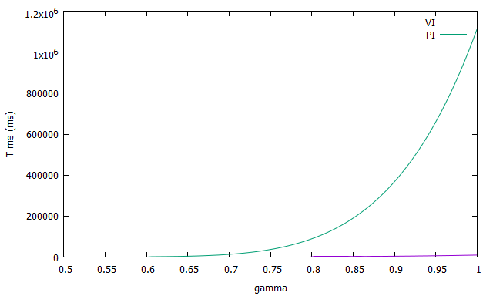

*Figure : Time vs gamma, Large grid world*

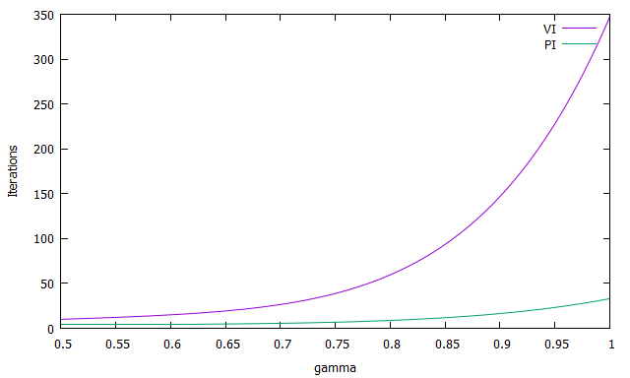

*Figure : Iterations vs. gamma, Large grid world*

**Policy Iteration**

Policy iteration can take a long time even though the equations for calculating the utilities are linear. When linear equations are being computed their matrixes are inverted. This process can still take a long time for large matrices. We have large matrices when we have a large number of states.

PI is usually faster because we do not need to find true utilities to find the policy. Why is that not working in this case?

PI is guaranteed to converge because the value iterations are always improving our estimate of the policy and there are a finite number of policies. If PI does not converge in this case it is because it is too computationally expensive.

Need to get O notation time needed.

Graph idead for all algs: number of steps taken to reach goal policy found by each alg.

**SARSA**

The running time for SARSA in the large grid world was

1.4266288E7 milliseconds or approximately 3.96 hours (this should be split in quarter, currently this is for running two algs for two trials) which prohibited it from being displayed on the figure with the other algorithms.

